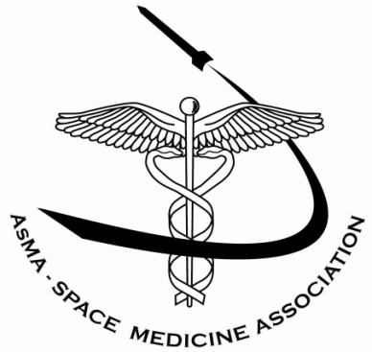
Space Medicine Association

Current Executive Officers:
Scott Parazynski, MD – President
William Tarver, MD – President-Elect
Steve Vander Ark, PhD – Secretary
Casey Pruett - Treasurer
Website: http://www.spacemedicineassociation.org/
Current Membership: 121 regular active, 47 lifetime active, 11 emeritus, 29 student, and 2 honorary

The Space Medicine Association of the Aerospace Medical Association has deep roots in the origins of the space race, and our current organization boasts a vibrant 210 engaged members involved in a wide variety NASA, international and commercial human spaceflight programs. These members range from active flight surgeons with NASA and international partner agencies, scientific researchers involved in human physiologic studies aboard the International Space Station, physician astronauts and students with an interest in the broad field of space medicine. The Space Medicine Association now is the sponsor of three annual scholarships, three annual awards, and several space medicine panels at each annual meeting. The organization continues to maintain a large endowment fund with the Aerospace Medicine Foundation.

The History of Space Medicine and the Birth of our Organization:

Following World War II, continued V-2 rocket research in the U.S. led many scientists to discuss the feasibility of human space travel. Gen. Harry Armstrong, M.D. organized a symposium at Randolph AFB on November 12, 1948 entitled “Aeromedical Problems of Space Flight” that featured presentations by Dr. Hubertus Strughold and an astrophysicist, Dr. Heinz Haber. Most professionals were highly skeptical of the subject and the presenters were considered as eccentrics for many years. This was followed up by a symposium on May 3, 1950, called the “Biological Aspects of Manned Space Flight” at the University of Chicago. Because of substantial interest, the presentations were collected and published as a book, “Space Medicine”, edited by Dr. Marbarger.
This led a small group of members of the Aero Medical Association (AMA) to explore the possibilities of establishing a professional organization dedicated to space medicine. After much debate in the Executive Committee the first constituent organization of the AMA was approved and the first meeting of the Space Medicine Branch was held on May 17, 1951. There were twenty founding members at this first meeting. Dr. Paul Campbell was elected President, Dr. Marbarger was elected President-Elect, and Dr. Strughold was elected Secretary.
Over the next several years, the organization grew steadily. This was probably due to the promotion of the field of space medicine and space travel in Colliers magazine (1952), by a Walt Disney TV special (1955) and by a dedicated article on space medicine in National Geographic in 1955. After the October 1957 launch of Sputnik, interest in space medicine exploded, resulting in an immediate expansion of membership, meeting attendance, presentations at the plenary sessions, and articles in the journal. In 1964, 1965, and 1966, Dr. Charles Berry chaired heavily attended sessions covering medical care during the Gemini Program at the Aerospace Medical Association (note the name change of the parent organization that was made in 1958) annual meeting. Under Dr. Berry’s leadership as the President of the organization in 1964, the organization continued to grow and receive international recognition. Enthusiasm for space medicine and the Space Medicine Branch continued at a high level for over 15 years and then leveled off as did the U.S space program in the 1970’s. However, membership and meeting attendance has never declined due to the continuation of the space program with the Shuttle missions, the biomedical research being carried on with the International Space Station and now the evolution of commercial human spaceflight.

