Right Ventricular Tissue Doppler in Space Flight

Kathleen M. Garcia¹, Douglas R. Hamilton¹, Michael R. Barratt ², Ashot E. Sargsyan¹, Douglas Ebert¹, David S. Martin¹,Valery V. Bogomolov^{4,} Scott A. Dulchavsky³, J. Michael Duncan²

- Wyle Integrated Science and Engineering, Houston, Texas
- National Aeronautics and Space Administration, Johnson Space Center, Houston, Texas
- Henry Ford Hospital Foundation, Department of Surgery, Detroit, Michigan
- State Research Center - Institute of Biomedical Problems of the Russian Academy of Sciences, Moscow, Russia

Funding for this research was provided under the NASA Bioastronautics Contract NAS9-02078.

Original work from the collaborative efforts of State Research Center for Russian Federation Institute of Biomedical Problems, NASA and the NASA contractor Wyle Integrated Science and Engineering, working under the Bioastronautics contract for Advanced Projects division of Space Medicine. This work is a portion of the data from the multilateral medical project “Validation of On-orbit Methodology for the Assessment of Cardiac Function and Changes in Circulating Volume using ‘Braslet-M’ Occlusion Cuffs”.
There are no conflicts to declare.
Reprint requests: K. Garcia Wyle Laboratories, 1290 Hercules, suite 430, Houston, Texas 77058 email kgarcia@wylehou.com.

Keywords: Right Ventricle Tissue Doppler, Braslet-M, Tei index, human space flight, space adaptation, microgravity

___________________________________________________________________________________

Abstract

Background
Tissue Doppler spectra depict motion of a chosen sample of heart tissue throughout the cardiac cycle. The right ventricle (RV) was examined with tissue Doppler (TD) for the first time in space crewmembers as a portion of an ongoing testing program “Braslet”. This is the first “space normal” set of RV TD spectra from an on-orbit reference group of five long-duration crewmembers.

Methods
RV tissue Doppler was performed by astronaut-scientists while remotely guided by an ultrasound (US) expert from Mission Control Center in Houston, Texas. The on-orbit reference group consisted of five subjects (4 male, 1 female, age mean 44 years). RVTD was obtained twice in each of these subjects at the free wall near the tricuspid annulus, in two separate sessions 4 to 7 days apart. A fifth subject’s RV TD was acquired in one session. Spectra in each session were obtained before (baseline) and following application of elastic occlusion thigh cuffs (Braslet-M device). Thus, a total of 18 DICOM data sets were analyzed with measurements of systolic, early diastolic, and late diastolic velocities and time intervals. The RV Tei index was calculated as an integral measure of myocardial performance.

Results and Discussion
The mean values across the reference group were used as on-orbit reference data. The late diastolic velocity 16.02 mean, with SD of 2.25. The Tei index was remarkably similar among all subjects (mean- 0.42; SD - 0.14). After the Braslet was tightened the late diastolic velocities dropped by 2.4% and the Tei index decreased by 15.5% to 0.34, SD of 0.06). However, Tei index even with acute fluid sequestration remained consistently larger in microgravity than the normal terrestrial Tei index (< 0.28). These data indicate changes in the RV preload in altered gravity are still incompletely understood. RV TD appears to be a tool that is sensitive to microgravity factors and to acute hemodynamic modification. Thus, the data set provides previously unavailable insight into certain aspects of RV physiology in microgravity a relatively understudied area with important implications for the clinical discipline of space medicine.

Introduction

The physiology of the right heart in human space flight is not sufficiently well studied due to inherent difficulty of obtaining proper echocardiographic views, as well as lower perceived priority compared to the left side. At the same time, right ventricle (RV) likely holds answers to a number of open questions in space physiology and clinical space medicine. Normal functional anatomy of the right ventricle (RV) is characterized by lengthening of the deep and superficial myocardial fibers in diastole and shortening of the myocardial fibers in systole, with preload and pressures lower than those of the left ventricle (LV) (4-6). RV function is characterized by compliant diastolic filling pressures affected by respiration and extracardiac pressures. Additionally, the shape and anatomy of the RV is different from the ellipsoidal shaped LV, making it a difficult structure for measuring volumes and function by two-dimensional echocardiography (1-3).

Echocardiography is available for research on the International Space Station (ISS), including the possibility to use RV tissue Doppler (TD). This report from the U.S. space medicine team is a pioneering work on tissue Doppler in controlled conditions on a microgravity-based human research laboratory. The data of this report were obtained as part of an ongoing testing program in long-duration spaceflight crews titled ”Validation of On-orbit Methodology for the Assessment of Cardiac Function and Changes in Circulating Volume using ‘Braslet-M’ Occlusion Cuffs (Braslet)”. The study protocol was approved for human testing by the NASA Johnson Space Center Committee for the Protection of Human Subjects.

The Braslet-M (Figure 1) consists of a set of custom elastic bands that is custom fit to all crewmembers prior to departing from Russia on board Soyuz spacecraft. This device is a Russian countermeasure to alleviate increased head ward fluid shift experienced in early phases of microgravity. The Braslets are worn on the crewmembers’ legs bilaterally and tightened to a prescribed tension. The Braslet-M is designed to cause fluid sequestration in the vascular bed and tissues of the lower extremities, reducing the effective circulating volume. The physiologic effect of the Braslet-M to circulation had not been formally studied by NASA. Anecdotal long duration crew feedback from both cosmonauts and astronauts indicated that the Braslets reduce ill effects or symptoms of microgravity exposure and allow for improved mental focus (A. Sargsyan personal communication).
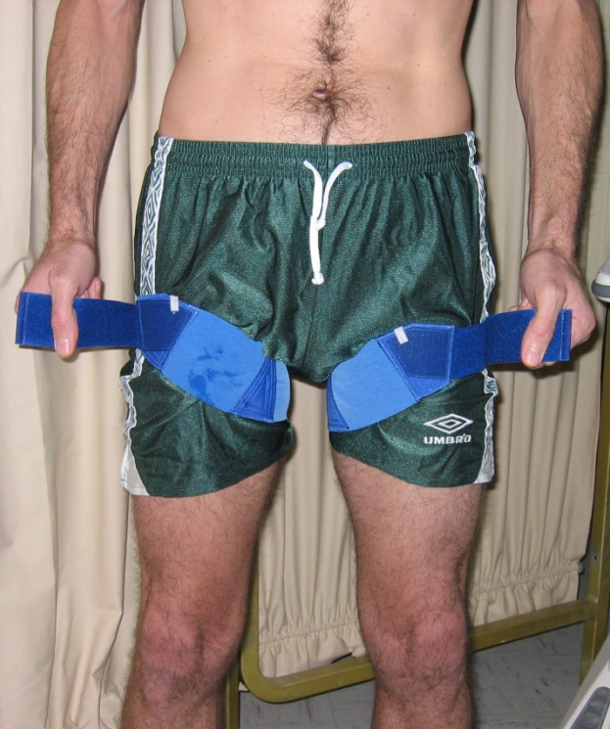 Figure 1. Pictured here is a set of Braslet-M that is contoured to a custom fit and worn bilaterally high on the legs. This example shows the Braslets in the released position. In flight the Braslets are tightened by the Velcro strap to a preflight prescribed in Russia. The setting is worn to alleviate the increased head ward fluid shift and negative physical symptoms of early space flight.

In echocardiography, TD is considered relatively independent of cardiac preload, geometry, respiration and heart rate (7-12).One purpose of this study is to test the reproducibility and fidelity of TD in the RV by relatively inexperienced ultrasound operators (i.e. astronauts). All terrestrial research on RV TD that is widely accepted is performed by experienced operators with their hands on the probe, but in this case the experts remotely guided this work from the ground. This experiment was performed using successful techniques previously described by Dulchavsky et al during the Advanced Ultrasound in Microgravity experiment (ADUM) where astronauts successfully utilized remotely guided echocardiography. Astronauts with limited or no medical background or previous ultrasound experience were remotely guided through complex echocardiography by a team of experts from Mission Control. (14-29)

The analysis of the right heart by echocardiography uses a combination of tools to describe complex right heart geometry, chamber sizes and motion. RV contraction and motion can be diagrammatically characterized for timing and velocity through spectral TD. Spectral TD is considered a reproducible, reliable clinical standard that is considered to be relatively pre load independent (8). Spectral Doppler measurement of two intervals from the tricuspid and pulmonary valves as previously described by Tei et al yields analogous information to that collected when the Doppler sample volume is placed at the RV freewall (7-10). Using this technique, velocities and timing are sampled from the lateral freewall of the RV near the inflow region at the tricuspid valve. These timing events from the reflected Doppler signals depict the isovolumetric relaxation, contraction and ejection phases of right ventricular function (figure 2) (7-11).

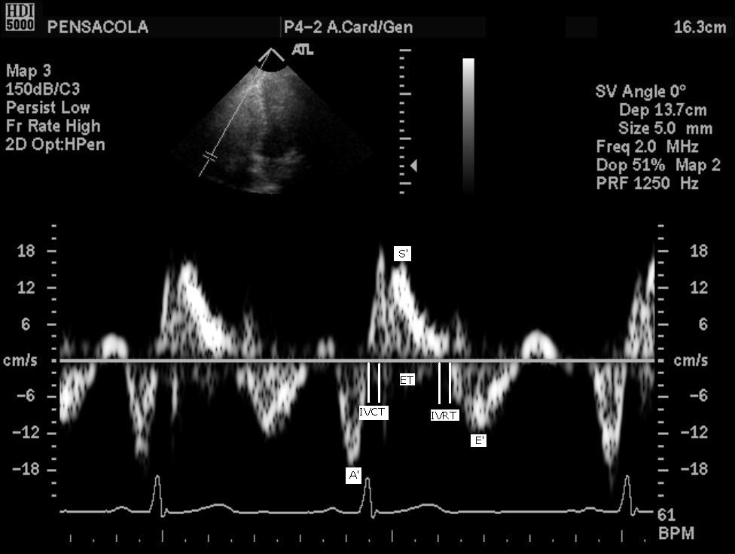
Figure 2. Tissue Doppler spectral signal: velocities and time intervals are analyzed from the right ventricle free wall with tissue Doppler

Timing of RV contraction occurs sequentially by separate regions and mechanisms beginning at the RV freewall, producing a bellows effect by shortening the long axis, contracting the longitudinal fibers, and creating traction at the RV free wall secondary to LV contraction. LV twisting and rotation does not contribute significantly to the RV contraction (3). Isovolumetric contraction time in the RV is also shorter than. RV systolic pressure equilibrates higher than pulmonary artery diastolic pressure.

Methods

The ISS Ultrasound System (HDI-5000), Philips/ATL, Bothell, Washington) was used to obtain TD spectra from the RV free wall near the tricuspid annulus through the apical window, before and after bilateral thigh compression with Braslet-M elastic devices (Kentavr-Nauka, Ltd., Moscow, Russia). RV TD spectra were analyzed to measure systolic (S’), early diastolic (E’), and late diastolic (A’) velocities, isovolumic contraction time (IVCT), ejection time (ET), and isovolumetric relaxation time (IVRT), and to calculate the index of Tei (Tei index = IVCT+ IVRT / ET). Transmitted images were digitally stored in the ISS ultrasound and transferred to mission control. Live video from the ultrasound scan head was also recorded and was later reduced to single image frames for analysis. All analysis was performed using Prosolv Cardiovascular (Indianapolis, IN) software. Measurements were performed over three consecutive hearts beats and averaged. The average and standard deviation between each parameter were measured. Following completion of baseline RV TD Doppler protocol the Braslet-M devices were donned to the prescribed tension and worn for ten minutes prior to re-acquiring cardiac TD measurements. Pre and post application Braslet-M data sets of RV TD were acquired during long duration spaceflight on four crewmembers. Total on-orbit duration prior to data sessions was between 34 and 111 days. The on-orbit reference group acquired two separate sessions 4 to 7 days apart. A fifth long duration crew member had a single session. Statistical analysis of the data set was performed comparing the effect of the Braslet-M. The analysis of the set of nine total scanning sessions with and without Braslet-M assumed an unstructured correlation matrix. A two-tailed Student’s t-test and chi-square distribution was used to make statistical comparisons due to the treatment and small sample size. Echocardiography imaging was performed by astronauts on fellow astronaut crewmembers or as ultrasound operators utilizing a self scanning technique (Figure 2) as previously described (14-30). Astronauts were remotely guided through application of the probe, system controls, and Doppler optimization by an echocardiography expert on the ground using private video and two way voice channels. Due to satellite communications, there was a 1.8 to 2 second delay in voice and video signal between the operator on-board the ISS and the sonographer in mission control.

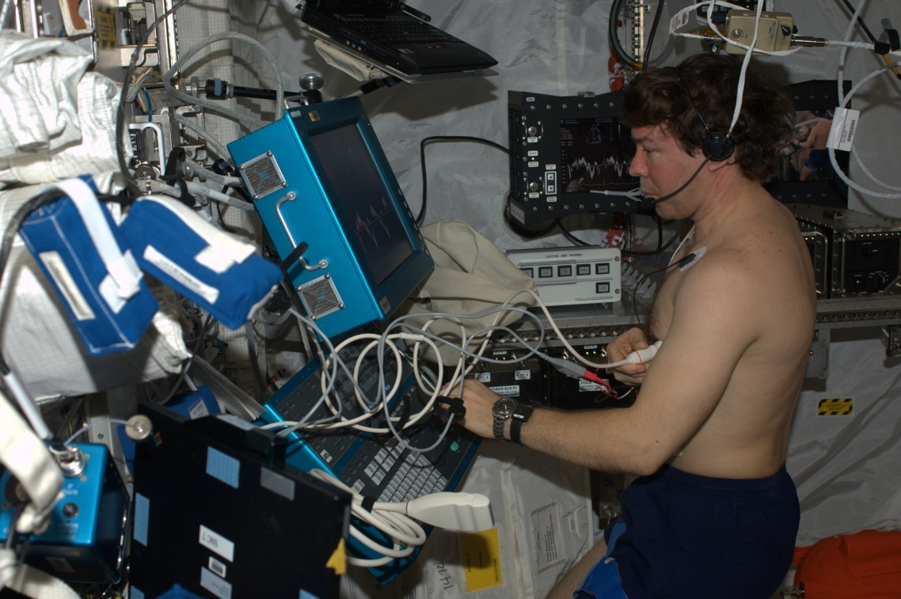
Figure 3
Astronaut Dr. Michael R. Barratt, Expedition 19 and 20 flight engineer is shown performing self scanning echocardiography on the ISS. Dr. Barratt is performing tissue Doppler with the Braslet-M device.

Results
Comparison of average S’, E’, A’, IVCT, ET, IVRT, Tei index, and Heart Rate device measured from tissue Doppler Echocardiography of five long duration astronauts, a total of nine data sessions are compared before and after application of Braslet-M. RV TD velocity signals expressed as velocity and percent change are compared in Table I.
After treatment with Braslet-M device the average Tei index (IVCT+IVRT/ET) for all subjects decreased from 0.42 to 0.34, a16.5% decrease, between first and second scanning sessions. HR after Braslet release decreased from 60.48 to 58.37 beats per minute, a 3.5% decrease (p=0.07).

Measurement | Pre Braslet | Post Braslet | Percent Change | P value
S’ | 14.14 | 14.89 | 1.9 | 0.52
E’ | 12.93 | 12.83 | 2.0 | 0.61
A’ | 18.36 | 16.30 | -0.2 | 0.19
IVCT | 93.82 | 68.68 | -17.7 | *
ET | 298.17 | 366.83 | -0.9 | *
IVRT | 90.46 | 55.28 | -24.9 | *
Tei=(IVCT+IVRT)/ET | 0.42 | 0.34 | -16.5 | 0.0026
HR | 60.48 | 58.37 | -3.5 | 0.07
Table I
Tissue Doppler velocities and time intervals from the Right Ventricle expressed as systolic velocity(S’), Early or rapid diastolic velocity( E’),late diastolic velocity (A’), isovolumetric contraction time from the end of the A’ wave to the onset of S’ (IVCT), ejection time or the duration of S’ (ET),Isovolumetric relaxation time or from the end of S’ to the onset of E’ (IVRT),Tei index= (IVCT+IVRT)/ET, and Heart Rate (HR).
Right ventricle tissue Doppler Echocardiography of five long duration astronauts, a total of nine data sessions are compared before and after application of Braslet-M acutely change the preload.
* Statistical relevance of the IVCT, ET and IVRT are considered factors that relate directly to the reduction as they contribute to the Tei index.

Discussion
This is the first set of space normal data from the RV TDand normal RT TD has not been investigated. In a recent case study Hamilton et al, documented RV TD in one crewmember along with the peripheral vascular cross-sectional areas, before and after Braslet-M release (13). In that case study the RV Tei index decreased with Braslet-M application. . Global myocardial performance referred to as the Tei index combines both systolic and diastolic parameters, and this index decreases with Braslet-M application in six of the nine data sessions. Normal terrestrial RV Tei index is less than 0.3 (8, 9, 11), and our data indicate that space normal Tei index may be higher. Because of the geometry of the RV free wall, the RV adapts to altering load and resistance relative to the intercavitary volume (3). During the initial phases of microgravity exposure, circulating volume is reduced, also reducing preload to the right ventricle. This fluid shift may result in a larger Tei index in the space-acclimated heart through the decrease in IVRT and IVCT. Reduction in IVRT and IVCT reflects a pattern of RV alterations in that timing before and after ejection is modified in the RV in response to the reduction in circulating volume. Global myocardial performance referred to as the Tei index combines both systolic and diastolic parameters and reduction in Tei index after the Bracelet-M is reflected by the shortening of the IVCT and IVRT. There is relatively little change in ejection time after reducing the circulating volume with Braslet-M. The acute volume change after Braslet-M application appears to affect preload though changes to RV relaxation times comparing to the data t after Braslet-M.
Braslet-M does not appear to significantly affect the velocity of the RV free wall after modification of the circulating volume. Systolic, early, and late diastolic RV velocities are comparable to those seen in a similar normal population on earth. There are no substantial changes in S’, E’ or A’ during preload reduction using Braslet-M. In the astronaut RV TD case study by Hamilton et al (13), E’ decreased 45% after the application of Braslet-M. Atrial systole (A’) increased with application of Braslet-M. In this overall data set neither changes significantly. Variations in velocity may be due to Doppler angle errors that can over- and underestimate the velocity (3) and is likely the result of off-axis imaging. The astronaut ultrasound operators for this experiment are relatively inexperienced scanners that are floating and not ‘optimally’ positioned for performance of echocardiography. Clinically, echocardiography is performed in a semi-lateral left decubitus position. As demonstrated in Figure 1, the astronauts are floating in microgravity and lying ‘down’ is relative. However, the RV TD timing intervals between events IVCT, IVRT and ET are not affected by Doppler angle. All TD signals achieved by the astronauts in this data subset were technically good signals with proper filter and gain making accurate time calculation possible. Errors in Doppler angle do not influence quality of the reflected signal but do affect resultant reflected velocity. Posture and the microgravity environment influence the position of the heart making some views unconventional which could also affect the base to apex velocity angle and therefore make velocity measurements somewhat variable.
In space-acclimated hearts, the RV TD time intervals appear to demonstrate a reliable reproducible tool for the purpose of studying RV movement. This work represents a small subset of individuals gathering TD through remote guidance appears to demonstrate that RV TD is reproducible can be used especially for measuring time intervals for global function. Tissue velocities from the RV appear to be relatively independent of acute volume changes showing no statistical difference between scanning sessions within our data. These findings are significant taking into consideration the astronaut scientists are not practiced echocardiographers without clinically acceptable training in Doppler or sonographers and should be considered noteworthy.

Limitations
This experiment was classified as a procedure verification of both the Braslet-M and the on-board ISS ultrasound therefore no echocardiographic data was collected preflight or post flight. There was a single echocardiographic orthogonal view of the RV taken during this experiment: the Apical 4 chamber view. Additional views from the parasternal window could reveal additional geometry for volume and mass calculations. The space-acclimated LV is thought to reduce in volume and mass. This study did not include multiple orthogonal views of the RV for means of measuring the RV volume and mass for comparison to LV nor did it include pre-flight imaging for comparison of gravity normal to space normal. Assessing RV volume and geometry would require further study to document change as a response to microgravity. RV volume and dimensions are not in the scope of this paper and remain for another publication.

Conclusion

Braslet-M has provided a means to acutely manipulate pre-load and test the consistency of RV TD, which has yielded unique physiological data. Previously, the effect of acute volume change to the RV was unknown in any group of long duration crew. Hemodynamic manipulation with the Braslet-M as a tool for assessing RV physiology in space can be useful as a non-invasive evaluation of RV function using the on-board ISS ultrasound from the long duration crew. The filling period of the RV is an indication of the effect of preload the Braslet-M has on the RV. However, because the compliance of the RV is thought to be greater than the LV and it is the compliance of the RV and the adaptation of space acclimatized heart that make this postulation difficult in this small sample size.
Further understanding of RV function could be significant to long duration crewmember cardiac health and requires additional review.
Increase in the Tei index indicates the presents of systolic or diastolic dysfunction. Dr Yoshifuku et al studied pseudo-normalized RV function after acute RV systolic or diastolic dysfunction (2). He explained that the decrease in IVCT associated with an increase in RV diastolic pressure. The RV diastolic pressure in microgravity may have increased after Braslet-M as we have a negative17percent change in IVCT after acutely changing the volume in these space acclimatized hearts. The RV in all the crew in this small sample has intact normal and compliant RV that are compensatory to changes volume. This study revealed a small but useful reference data set for future clinical and research studies in echocardiography and further study of the right side of the heart. Clinically there are limited tools to evaluate RV physiology and function non-invasively. The combination of the Braslet-M and RV TD reacting to acute volume changes on hearts acclimated to space may reveal important information about cardiovascular function and circulating volume status of crewmembers. This is the first group of data demonstrates the use of from the RV using a clinically relevant tool that can be implemented easily by astronauts on-board the ISS. RV TD should be considered a tool to help understand the effect of preload on the space acclimated heart.

References

- R.F. Rushmer, D.K. Crystal, C.W.Wagner. The Functional Anatomy of Ventricular Contraction. Circulation 1952, Oct 27
- F. Haddad, S.A. Hunt, D.N. Rosenthal, D.J. Murphy. Right Ventricular Function in Cardiovascular Disease, Part 1: Anatomy, Physiology, Aging, and Functional Assessment of the Right Ventricle. Circulation 2008;117;1436-1448
- A. Weyman et al. R.J. Bussy editor, Harvard Medical School, Boston, Mass, Principles and Practice of Echocardiography, 2nd ed.- Williams and Wilkins, Media, PA, USA:1994.pp901-921 and pp13-216.
- Perhonen M, Zuckerman JH, Levine BD, "Deterioration of left ventricular chamber performance after bed rest: "Cardiovascular deconditioning" or hypovolemia?" Circulation, 103:1851-1857, 2001
- M.A. Perhonen, F. Franco, L.D. Lane, J.C.Buckey, C.G.Clomqvist, J.E. Zerwekh, R.M. Peshock, P.T.Weatherall, B.D. Levine. Cardiac atrophy after bed rest and spaceflight. J of Appl Physiology 2001, Vol. 91, Issue 2,645-653
- Levine BD, Zuckerman JH, J.A. Pawelczk. Cardiac atrophy after Bed-Rest Deconditioning: A nonneural mechanism for orthostatic intolerance. Circulation 1997, Vol. 96, 517-525
- K. T. Spencer, J.N. Kirkpatrick, V. Mor-Avi, J. M. Decara, R. M. Lang. Age Dependancy of the Tei Index of Myocardial Performance. J. of American Soc. Echocardiography 2004, April, Vol. 17, Issue 4,pp 350-352
- C.Tei, K. Dujardin, D.O. Hodge, K.R. Bailey, M.D. McGoon, A.J. Tamjik, J.B. Seward. Doppler Echocardiographic Index for Assessment of Global Right Ventricular Function. J. of American Soc. Of Echocardiography 1996
- K. D. Horton, R.W. Meece, J. C. Hill. Assessment of the Right Ventricle by Echocardiography: A Primer for Cardiac Sonographers. J of American Soc. Echocardiography 2009, July, Vol. 22, Issue 7, pp 776-792
- L. E. Sade, O. Gulmez, U. Ozyer, E. Ozgul, M. Agildere, H. Muderrisoglu. J of American Soc. Echocardiography 2009 April, Vol. 22, Number 4, pp361-367
- Tei C, Nishimura RA, Seward JB, Tajik AJ. Noninvasive Doppler-derived myocardial
performance index: correlation with simultaneous measurments of cardiac catheterization measurements 19. 1997;19:169-78.
- Boissiere, J. et al. Pulsed Doppler tissue imaging of the velocity of tricuspid annular systolic motion. A new, rapid, and non-invasive method of evaluating right ventricular systolic function.
2005Am J Physiol Heart Circ Physiol vol:10.1152,00524
- Hamilton et al. Right Ventricular Tissue Doppler Assessment in Space during Circulating Volume Modification using the Braslet-M Device. 2009 Acta AstronauticaReference List
- Beck, G., S. Melton, and S. A. Dulchavsky. "Critical care medicine in space." Aviat.Space Environ.Med. 76.2 (2005): 163.
- Benninger, M. S., et al. "Ultrasound evaluation of sinus fluid levels in swine during microgravity conditions." Aviat.Space Environ.Med. 80.12 (2009): 1063-65.
- Chiao, L., et al. "Ocular examination for trauma; clinical ultrasound aboard the International Space Station." J.Trauma 58.5 (2005): 885-89.
- Dulchavsky, S. A., et al. "Thoracic ultrasound diagnosis of pneumothorax." J.Trauma 47.5 (1999): 970-71.
- Dulchavsky, S. A., et al. "Advanced ultrasonic diagnosis of extremity trauma: the FASTER examination." J.Trauma 53.1 (2002): 28-32.
- Dulchavsky, S. A., et al. "Prospective evaluation of thoracic ultrasound in the detection of pneumothorax." J.Trauma 50.2 (2001): 201-05.
- Fincke, E. M., et al. "Evaluation of shoulder integrity in space: first report of musculoskeletal US on the International Space Station." Radiology 234.2 (2005): 319-22.
- Foale, C. M., et al. "Diagnostic instrumentation aboard ISS: just-in-time training for non-physician crewmembers." Aviat.Space Environ.Med. 76.6 (2005): 594-98.
- Kirkpatrick, A. W., et al. "Trauma sonography for use in microgravity." Aviat.Space Environ.Med. 78.4 Suppl (2007): A38-A42.
- Kirkpatrick, A. W., et al. "Thoracic sonography for pneumothorax: the clinical evaluation of an operational space medicine spin-off." Acta Astronaut. 56.9-12 (2005): 831-38.
- Kirkpatrick, A. W., et al. "Hand-held thoracic sonography for detecting post-traumatic pneumothoraces: the Extended Focused Assessment with Sonography for Trauma (EFAST)." J.Trauma 57.2 (2004): 288-95.
- McFarlin, K., et al. "A surgeon's guide to the universe." Surgery 139.5 (2006): 587-90.
- Otto, C., et al. "Into thin air: extreme ultrasound on Mt Everest." Wilderness.Environ.Med. 20.3 (2009): 283-89.
- Rao, S., et al. "A pilot study of comprehensive ultrasound education at the Wayne State University School of Medicine: a pioneer year review." J.Ultrasound Med. 27.5 (2008): 745-49.
- Sargsyan, A. E., et al. "Ultrasound detection of simulated intra-ocular foreign bodies by minimally trained personnel." Aviat.Space Environ.Med. 79.1 (2008): 58-61.
- Sargsyan, A. E., et al. "FAST at MACH 20: clinical ultrasound aboard the International Space Station." J.Trauma 58.1 (2005): 35-39.

