Percutaneous Aspiration of Intra-Peritoneal Fluid in Weightlessness: A Potential Component for the Management of Secondary Peritonitis in Deep Space

¹A.W. Kirkpatrick, ²M. R. Campbell, ¹S. Nicolaou, ²A.E. Sargsyan, ³S.A. Dulchavsky, ²S. Melton, ⁴D. L. Dawson, ⁴R. D. Billica, ⁴D. R. Williams, ⁴S. L. Johnston, ²D. R. Hamilton

¹Vancouver General Hospital Vancouver, British Columbia.
²Wyle Life Sciences, Houston, TX.,
³Wayne State University Detroit, MI.
⁴Space and Life Science Directorate National Aeronautics and Space Administration Houston, TX.,

(Address for Correspondence)

AW Kirkpatrick MD FRCSC

Trauma Services

Vancouver Hospital & Health Sciences Centre

3rd Floor, 855 West 10th Avenue

Vancouver, British Columbia

V5Z 1L7

(604) 875-4559
(604) 875-5348 (fax)
andykirk@istar.ca or akirkpat@vanhosp.bc.ca

This Manuscript has been referenced using Procite 4.0 Reference Manager

Abstract

Background Introduction: Secondary peritonitis is a medical emergency usually requiring surgery. Often fatal without appropriate treatment, peritonitis can affect even well-screened, healthy individuals. If an astronaut develops peritonitis during a long-duration space exploration mission, resource constraints and environmental factors may dictate deviations from traditional terrestrial medical approaches. Medical management can successfully treat many intra-abdominal processes that lead to secondary peritonitis, but treatment failures are inevitable. Percutaneous aspiration with real time sonographic guidance can provide “rescue” from the need for emergency surgery by providing a drainage route for abscesses or infected enteric contents without the physiologic consequences or logistical requirements of surgery. Percutaneous fluid aspiration has not previously been reported in weightlessness.
Hypothesis: Successful sonographically guided percutaneous aspiration of intra-peritoneal fluid can be performed with attention to restraint of the subject, operators, and equipment.
Methods: Investigations were carried out in the weightless environment of NASA’s KC-135 research aircraft (0g). The study subjects were a series of fully anesthetized female 50kg Yorkshire pigs. The procedures were rehearsed in a terrestrial animal lab (1g). Prior to flight, intra-peritoneal catheters were placed, and 500cc of colored saline introduced during flight. Both high-definition broadband (HDI-5000A, ATL, USA) and a 2.4 kg portable handheld (Sonosite 180, Sonosite, WA) ultrasound systems were used to guide the percutaneous placement of a 16 gauge needle into the peritoneal cavity and to aspirate the fluid. Still digital and analogue video recordings were made the aspiration.
Results: Intra-peritoneal fluid collections were easily identified in sub-peritoneal locations, that were distinct from surrounding viscera, and on occasion became more obvious during transition from hypergravity to weightless conditions. The aspiration needle could readily be followed during the insertion phase and fluid easily withdrawn from the peritoneum. The subjective difficulty was no more demanding with adequate restraint of the subject and operators than during the 1g rehearsals.

Conclusions: Sonographically directed percutaneous aspiration of intra-peritoneal collections is feasible in weightlessness. Open and endoscopic surgical interventions could be performed if the equipment and trained operators were aboard. Given practical limitations, alternatives could involve a primary emphasis on pharmacologic treatment of most inflammatory conditions that can lead to peritonitis, with secondary reliance on a sonographically guided percutaneous aspiration for the rescue of treatment failures. This compromise strategy may simplify treatment in an operational setting. This strategy cannot guarantee the return to health of all afflicted but may have the highest level of practicality given resource limits.

Keywords: Weightlessness, Space Flight, Peritonitis, Surgery, Percutaneous Drainage

Introduction

With the reality of the International Space Station (ISS), planning is beginning for future exploratory space missions. A manned mission to Mars is planned for his century. Addressing the care and management of intra-abdominal conditions are a high priority for space medicine because there are a number of potentially fatal disease processes that can arise in the previously healthy young adult. Emergent surgical conditions such as acute appendicitis are potentially disastrous to both an individual’s health and the entire mission⁶ ²⁰ ²² ³⁰ (Trunkey 1992)(Trunkey 1986)(MCCuaig 1992)(Campbell 93)(McCuaig 1994). Acute surgical emergencies have already been considered in the differential diagnosis of previous Russian space illnesses³ ⁴(Campbell 1998)(Trunkey 1986)(Campbell 1992 blue). The most common and hence likely surgical emergencies are the spontaneous causes of secondary peritonitis; appendicitis, perforated peptic ulcers, perforated sigmoid colon (diverticulitis, volvulus, or cancer), strangulation or obstruction of the small intestine, necrotising pancreatitis² ²⁷. Intra-abdominal abscesses are a sequalae of these conditions that may arise in the course of disease, even with the best of treatment.

Often these conditions may arise without there being any pre-existing signs that would allow detection during pre-flight screening. Acute appendicitis afflicts one in seven individuals at some point in our lives³¹. Risk factors for diverticulitis, neoplastic obstruction, inflammatory bowel disease, or pancreatitis may not be detected through detailed pre-flight testing. New conditions may arise during a five year mission, especially with an older astronaut population or due to the many physiological stressors to be faced in space¹⁶. None the least of which includes ionizing radiation with carcinogenic risks. Gene probe testing has the potential to detect genetic pre-disposition to various serious disease, but has limited scope at present and unresolved ethical issues¹⁵.

Unless a palliative approach to serious illness and injury is decided upon for a potential Mars mission, the ability to treat intra-abdominal pathology predisposing to peritonitis will be required. A limited number of studies have examined formal open and minimally invasive surgery in weightlessness. These studies have demonstrated that surgical procedures are feasible, but realistic logistical constraints may override this need. The likely approach will be medical management of inflammatory conditions such as appendicitis as it is now practiced in the submarine population. With an evacuation delay of 9 to 12 months for a Mars Mission required for a treatment failure though, a “rescue” option will be required for these failures. Image guided percutaneous aspiration of fluid is a potential rescue approach that has never been reported before in weightlessness.

Methods

Four (n = 4) fifty (50 kg) female Yorkshire pigs were used as the experimental model. Ethical approval was obtained for the study from the NASA/JSC, University of Texas Medical Branch-Galveston, and the University of British Columbia Animal Use Committees. The procedures conformed to the NIH Guidelines for the Care of Laboratory Animals. The animal was prepared at an offsite animal facility (UTMB-Galveston) prior to transport to Ellington Field, Texas for the flight. The animals were anesthetized with pentobarbital, intubated, and maintained with intravenous pentobarbital. Arterial and venous catheters were inserted and a foley catheter was placed to drainage. A single midline 8 french gauge radiopaque 23.5 cm peritoneal lavage catheter (Arrow International, Reading, PA) was inserted using a closed Seldinger technique. Laparoscopic ports were also placed under direct and laparoscopic visualization in order to perform further sonographic and laparoscopic investigations (not reported herein). The animals were ventilated with a portable transport ventilator (Model 754 Impact Instrumentation, Caldwell, NJ), and closely monitored with EKG, arterial blood pressure, tidal volume, oximetry, and end tidal capnography.

Zero gravity (0g) studies were performed onboard the NASA KC-135 aircraft during parabolic flight. Each parabola consisted of two phases lasting approximately 2 minutes; 30-40 seconds of 2g followed by approximately 15-20 seconds of transition, followed by 30-40 seconds of 0g flight followed by another transition period. The animal, life support, monitoring equipment, and ultrasound equipment were secured to the aircraft floor for parabolic flight prior to takeoff. (figure 1.).

Diagnostic imaging was performed with an Advanced Technologies Laboratory model HDI 5000 ultrasound system (Bothell, Wa) that is functionally identical to the repackaged model designed to fit within the Human Research Facility (HRF) rack in the laboratory module of the International Space Station Human Research Facility. The 2.75 mHz curved array transducer used for this experiment was also identical to that being flown with the HRF ultrasound. A portable 2.4 kg portable handheld (Sonosite 180, Sonosite, WA) was also used for imaging. The output from both ultrasound units was visualized real-time on a separately mounted monitor and was video-recorded and annotated for later analysis.

Prior to the percutaneous interventions 500 cc of colored saline was instilled in the peritoneal cavity through the peritoneal lavage catheters. An 18 gauge 6.35 cm XTW needle with a 5 cc Arrow Raulerson syringe (Arrow International, Reading, PA) was utilized for intra-peritoneal imaging and fluid aspiration. The aspiration procedure was rehearsed in a ground lab animal facility to familiarize the operators with the technique, anatomy, and fluid behavior in the porcine peritoneal cavity. During the flight phase, ultrasound of the abdomen and pelvis was performed during all phases of the flight to evaluate human factors, ultrasound image quality, visualization of the intra-peritoneal fluid collections, and the feasibility of real time fluid aspiration in weightlessness.
The intra-peritoneal fluid collection was visualized during the 0g, 2g, and transition portions of the flight profile. Actual aspiration of fluid was done during the 0g maneuver. The return of colored fluid with aspiration along with imaging of the needle within the fluid collection was used as a indicator of task completion.

Results

Percutaneous aspiration of intra-peritoneal fluid collections was easily carried out in weightlessness. The operators were able to direct the needle into the peritoneal cavity under sonographic guidance (figure 2.)
. This was possible both with a single operator directing their own needle, and with pair of operators, one imaging the peritoneal cavity and the other directing the needle (figure 3.). The aspiration was done in the right lower quadrant of 4 different animals. Colored fluid was returned by the operators confirming the successful aspiration. The procedure in weightlessness was judged to be no more difficult when compared to the ground lab practice sessions. There was also no difficulty in generating clear images of the intra-peritoneal fluid without gravity. Subjectively the intra-peritoneal fluid collections appeared to become more prominent and accessible during transition from normal of hypergravity to weightlessness.

Discussion

The ability for physicians to percutaneously aspirate fluid collections from the peritoneal cavity of a 50 kg pig under real-time sonographic guidance was demonstrated in weightlessness. This proved no more difficult than rehearsals in 1g in the animal laboratory. The procedure was also easily performed by both radiologists with extensive experience (SN, AS), and surgeons with only moderate experience (AK, MC, SD). The fluid was easily identified as anechoic areas that were contrasted against contiguous loops of bowel, the bladder, and the abdominal wall and peritoneum. The intra-peritoneal fluid could be well visualized in weightlessness. Without gravity intra-peritoneal fluid no longer collects in the most dependant portions of the peritoneal cavity as “dependency” has no meaning. Surface tension and capillary action are the physical forces that determine intra-peritoneal fluid behavior⁶ ¹⁶ ²¹. Without gravity, saline solutions, blood, and enteric fluids form large fluid domes when exposed, and become inherently cohesive⁵ ⁹. The intra-peritoneal saline was only a surrogate for a true intra-peritoneal abscess which would be normally surrounded by a fibrinous capsule that would further localize fluid collections. This investigation has shown that percutaneous drainage of intra-peritoneal fluid in weightlessness is feasible and practical. How might it fit in to a potential strategy for treating secondary peritonitis in the constrained environment of deep space flight?

Secondary peritonitis may complicate almost any abdominal condition be it infective, ulcerative, obstructive, neoplastic, or traumatic¹². It is the “usual” form of peritonitis that may strike the young and previously healthy without prior warning, and is usually secondary to some breach of the gastrointestinal tract¹⁴ ¹⁸. Peritonitis is a severe threat to life, with reported mortality rates ranging from 1 to 60% despite therapy representing heterogeneity in the patients reported² ¹⁸ ²⁹. Fortunately recent medical and surgical advances have changed the demographics of peritonitis and its victims, through such measures as better pharmacological treatment of peptic ulcer disease with reduced perforations, and the earlier removal of appendices prior to gangrene¹². Figures from only a generation ago revealed the causes of peritonitis to be from acute appendicitis (up to 50% of cases), perforated peptic ulcer (up to 25%), with an array of other causes comprising the rest¹². The presence of peritonitis usually is synonymous with early laparotomy and surgical repair (with certain particular exceptions)¹⁸. The principles of management of secondary peritonitis consist of; (1) the early diagnosis of causative lesions, (2) assessment of the risk of peritonitis, (3) early removal of the cause. In this setting antibiotics are an adjunct and not the mainstay of therapy. Theoretically episodes of acute peritonitis could be prevented by removing every inflamed appendix, relieving every obstructed intestinal segment, or repairing every perforated duodenal ulcer, at the very instant the pathology began. In this way the ravages of systemic inflammatory activation with the to common pathway towards the systemic inflammatory response syndrome (SIRS), sepsis, shock, and multi-system organs dysfunction (MODS) could be avoided. This is not possible in the best medical centers on earth, and will certainly not be practical onboard a spacecraft in deep space.

As the International Space Station (ISS) continues to develop, planners are already dealing with medical issues required to plan a mission to Mars. There is obviously no prior experience in interplanetary travel to draw on. The closet situation is that of the long duration Russian space experiences, which are still around the one year duration for the longest inhabitants. An acute abdominal emergency with peritonitis has not occurred but was suspected in one cosmonaut who eventually recovered³. Epidemiologic studies of submarine personnel and personnel stationed in the Antarctica reveal that major surgical events are rare but catastrophic to the mission or program³. The luxury of a quick return to definitive earth care though, will not be an option during a Mission to Mars. With current propulsion systems a Mars mission may entail a 2 to 4 year voyage¹¹, with time to definitive medical care of 9 to 12 months if an evacuation was required³. It is unknown whether a surgeon or even a physician will be a crew-member. It is assured that medical capabilities will be severely restrained by mass, volume, power, and personnel restrictions. While the original Space Station Freedom was intended to provide the capacity to perform major intra-abdominal surgery, this capability was not included on the ISS²⁸. Unless a medical care strategy is accepted that intends only to palliate and reduce the suffering associated with an astronauts death, then the means to respond to a surgical emergency threatening secondary peritonitis is required.

The Zero Gravity Program at the National Aeronautics and Space Administration has utilized parabolic flight in the KC-135, a modified Boeing 707 for many years to study the characteristics of many medical procedures in a weightless environment. By flying a Keplerian or ballistic profile this aircraft can generate approximately 30 second intervals of effective weightlessness.

Investigators have studied a wide range of critical care and surgical procedures in the analogue space environment of parabolic flight. This has required the parceling up of complicated procedures into segments, or by examining only the most crucial, or rate limiting parts of a procedure. Simulations performed aboard the KC-135, have demonstrated the ability to perform endotracheal intubation, mechanical ventilation, cardiopulmonary resuscitation (CPR), intravenous access with infusion of fluids and medications, intravenous anaesthetic techniques, central arterial, central venous and intracerebral pressure monitoring, debriding, suturing, and cleansing of wounds, splinting and casting of limbs, and the insertion of urinary and nasogastric catheters, using either training mannequins or animal models⁴ ⁷ ¹⁷ ¹⁹⁻²² . Open surgical procedures on anaesthetised animal models have included; exploratory laparotomy, mesenteric vein ligation and repair, and incision and repair of; renal artery, carotid artery, and aorta, as well as laparotomy incision closure⁶. Endoscopic procedures have included, laparoscopy and laparoscopic surgery techniques⁵, and thoracoscopy and thorascopic techniques⁹. The cumulative experience of these innovative but limited investigations has suggested that surgery in space should be quite feasible with proper preparation and planning³ ⁴ ⁶ ²⁰ ²² ²⁶ ³⁴.

While definitive surgical interventions in standard open fashion or minimally invasive are the most desirable it is likely that neither the operators nor the equipment will be on-board the first mission to Mars to provide this. The next best approach may be that of adopting a non-operative pharmacological treatment protocol³. The successful non-surgical treatment of appendicitis in submariners and professional hockey goalies is such an example¹. It is also routine surgical practice to initially treat acute cholecystitis and diverticulitis medically in select patients, with the expectation of improvement to allow an elective rather than emergent operative interventions²⁴ ³³. Any non-operative strategy such as this would have to anticipate and plan for treatment failures whose intra-abdominal process continues to progress. These patients would be the group that would benefit from a percutaneous drainage approach.

The percutaneous drainage of intra-abdominal abscess is an accepted mainstay of appropriate therapy² ¹⁴ ³². It is generally done either with computed tomographic or sonographic guidance ¹³ ¹⁸ ²⁷. The percutaneous drainage (PCD) of infected contents has spared many patents from urgent surgical procedures²⁵ ³². Simple, well-defined abscesses without enteric communication or internal loculation will be successfully treated by PCD in up to 90% of cases ² ¹³ ¹⁸ ³². One hundred percent success rates have been reported for abscesses resulting from cases of appendicitis, the most likely disease process expected in space²⁷. Successful percutaneous management of cases of both perforated duodenal ulcers with associated abscesses, and even cases of inflammatory bowel disease associated with enteric fistulae have been reported¹⁰ ²³

It remains unknown what skill set the crew medical officer (CMO) will carry to a Mars mission. With extensive reference material and decision support software it will be desirable to technical skills which cannot be transmitted or stored, rather than information or knowledge which can(Kirkpatrick 1997). Especially if a CMO was not facile at the percutaneous approach, the instantaneous feedback of real-time sonography would add an element of safety to the picture. The ISS has only sonography aboard as the only imaging modality in space. A Mars vessel might have other imaging capabilities such as computed tomography, but even after CT locates a collection, sonography can be quite easily used to direct the needle in a safer fashion than blind. It has been estimated that the time delay involved in sending the electronic signal between Earth and Mars will take between 8 and 50 minutes depending on the orbital configurations of the planets³ ⁸. The transmission would be quicker the closer to the earth the space vessel was, but real time telerobotic or even telementored control would not be possible. Advances in technology and 3D ultrasound though might permit an robotic approach once the system had fixed local co-ordinates with a manual over-ride for safety by the on-site CMO. In this way intra-abdominal abscesses arising from unsuccessful medical management of appendicitis, diverticulitis, pancreatitis, or even perforated peptic ulcers might be treated. If the equipment, and potentially even more enabling, the personnel were available to perform this type of intervention a logical progression might be the early decompression of obstructed ducts and visci prior to system sepsis and toxicity. The successful completion of a percutaneous cystostomy in weightlessness by our group is an example (Dulchavsky SA, personal communication). The decompression of a acute chemical cholecystitis prior to the onset of bacterial infection would be another.

Conclusions

Sonographic guided percutaneous drainage is very feasible in weightlessness with simple logistical supplies once ultrasound is available. This technique could be used to provide a “rescue” therapy for intra-abdominal abscesses associated with during medical illnesses associated secondary peritonitis during deep space exploration. With limited surgical capabilities serious conditions that have traditionally been dealt with through early surgery will likely be treated pharmacologically, raising the potential for treatment failures. Intra-abdominal abscesses and other infected fluid collections may be the result. Assuming similar success rates in space as on earth, predicts that a patient could be spared the need for operative surgery in the majority of cases. While definitive surgical capabilities are desirable for eventual deep space care, percutaneous aspiration techniques are a potentially powerful and life-saving addition to the space medicine armamentarium.

Acknowledgements

This work was supported in part by the NASA Johnson Space Center and Wyle Life Sciences, Houston, Texas. We are extremely grateful for the technical support of Terry Guess, Dr. Gary Latson, Dr Rosa Chun, the staff of the University of Texas Medical Branch, Galveston Texas, Kristine Gillespie of the Jack Bell Research Centre, Vancouver, Canada, and the Advanced Therapy Laboratories Ultrasound Company for use of the ATL 5000 ultrasound machine.

Figures

Figure 1. Parabolic flight set-up showing sonographic monitors configured in forward viewing screen of investigators with sonographic hardware and instrument console configured for second sonographer. All equipment restrained aboard the KC-135 aircraft.

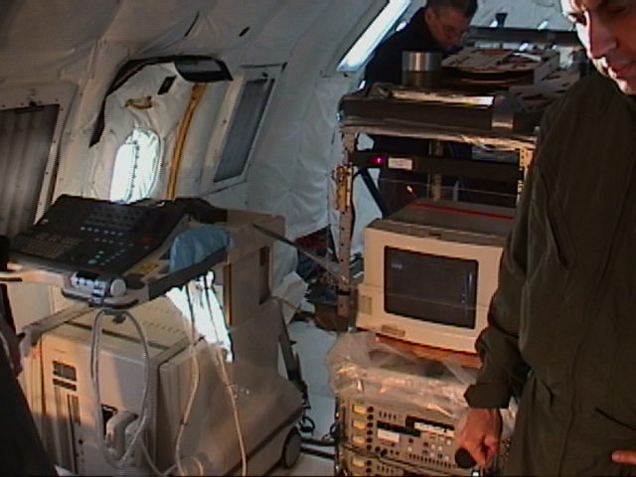

Figure 2. Sonographic image of percutaneous needle positioned within an intra-peritoneal collection of free fluid.

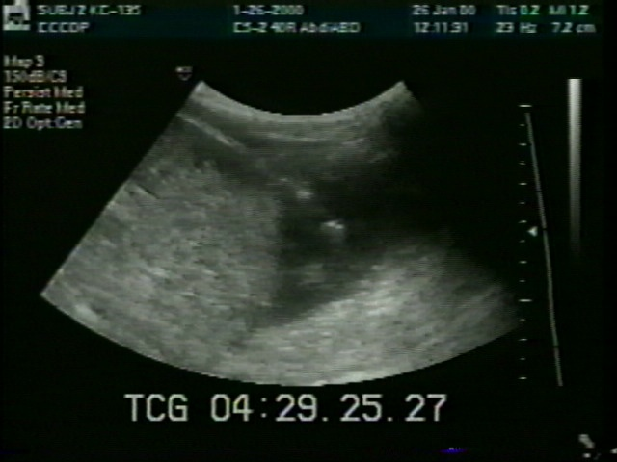

Figure 3. Investigative set-up for performing percutaneous fluid aspiration in weightlessness. Two person technique where sonographer directs sonographic probe and second operator performs percutaneous aspiration. A single person technique was also successful (see text).

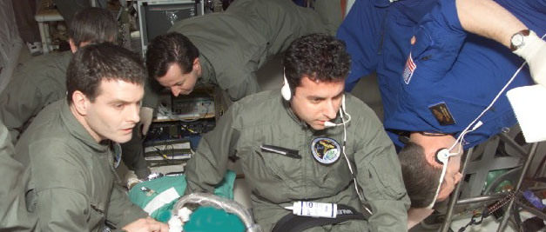

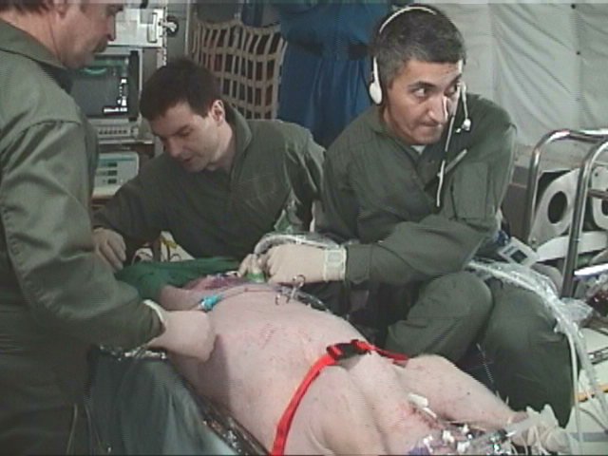
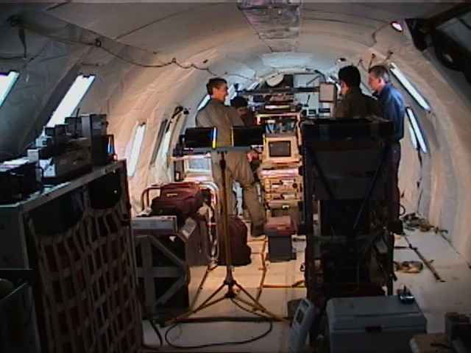

Reference List

1. Adams ML. The medical management of acute appendicitis in a nonsurgical environment: A retrospective case review. Mil Med 1990; 155:345-7.
2. Baker CK. Peritonitis and intra-abdominal abscess. Cameron JL, editor. Current Surgical Therapy. 5th ed edition. St. Louis, Missouri: Mosby , 1995: 943-7.
3. Campbell MR. Surgical care in space. Aviat Space Environ Med 1999; 70:181-4.
4. Campbell MR, Billica RD. A review of microgravity surgical investigations. Aviat Space Environ Med 1992; 63:524-8.
5. Campbell MR, Billica RD, Jennings R, Johnston SL. Laparoscopic surgery in weightlessness. Surg Endosc 1996; 10:111-7.
6. Campbell MR, Billica RD, Johnston SL. Animal surgery in microgravity. Aviat Space Environ Med 1993; 64:58-62.
7. Campbell MR, Billica RD, Johnston SL. Surgical bleeding in microgravity. Surg Gynecol Obstet 1993; 177:121-5.
8. Campbell MR, Johnston SL, Billica RD. Exploration life support issues panel future of surgical care in space. Proceedings of the American Institute of Aeronautics & Space Exploration Initiative.
9. Campbell MR, Kirkpatrick AW, Billica RD et al. Endoscopic surgery in weightlessness. Surg Endosc (in press).
10. Casola G, vanSonnerberg E, Neff CC, Saba RM, Withers C, Emarine CW. Abscesses in Crohns disease: percutaneous drainage. Radiology 1987; 163:19-22.
11. Davis JR. Medical issues for a mission to Mars. Texas Medicine 1998; 94:47-55.
12. Ellis H. Acute secondary peritonitis. Schwartz SI, Ellis H, Editors. Maingot's Abdominal Operations. 9th ed edition. Norwalk, CT: Appelton & Lange, 1990: 341-51.
13. Jamieson DH, Cait PG, Filler R. Interventional drainage of appendiceal abscesses in children. AJR 1997; 169:1619-22.
14. Jawa RS, Solomkin JS. Peritonitis and intraabdominal abscess. Cameron JL, editor. Current Surgical Therapy. 6th ed edition. St. Louis, Missouri: Mosby, 1998: 1082-6.
15. Kim HN. Prescription for prophecy: Confronting the ambiguity of susceptibility testing. JAMA 1998; 280:1535-6.
16. Kirkpatrick AW, Campbell MR, Novinkov O, Goncharov I, Kovachevich I. Blunt trauma and operative care in microgravity. J Am Coll Surg 1997; 184:441-53.
17. Markham SM, Rock JA. Microgravity testing a surgical isolation containment system for space station use. Aviat Space Environ Med 1991; 62:691-3.
18. McClean KL, Sheehan GJ, Harding GKM. Intraabdominal infection: A review. Clin Infect Dis 1994; 19:100-16.
19. McCuaig K. Aseptic technique in microgravity. Surg Gynecol Obstet 1992; 175:466-76.
20. McCuaig K. Surgical problems in space: An overview. J Clin Pharmacol 1994; 34:513-7.
21. McCuaig K, Lloyd CW, Gosbee J, Synder WW. Simulation of blood flow in microgravity. Am J Surg 1992; 164:119-23.
22. McCuaig KE, Houtchens BA. Management of trauma and emergency surgery in space. J Trauma 1992; 33:610-25.
23. Raafat NA, Dawson SL, Mueller PR. Case report: Combined conservative and percutaneous management ofa perforated duodenal ulcer. Clin Radiol 1993; 47:426-8.
24. Rothberger DA, Garcia-Aguilar J. Diverticular disease of the colon. Cameron JL, editor. Current Surgical Therapy. 6th ed edition. St Louis, Missouri: Mosby, 1998: 173-9.
25. Sahai A, Belair M, Gianfelice D, Cote S, Gratton J, Lahaie R. Percutaneous drainage of intra-abdominal abscesses in Crohn's disease: Short and long term outcomes. Am J Gastroenterol 1997; 92:275-8.
26. Satava RM. Surgery in space. Phase I: Basic surgical principles in a simulated space environment. Surgery 1988; 103:633-7.
27. Shuler FW, Newman CN, Angood PB, Tucker JG, Lucas GW. Nonoperative management for intra-abdominal abscesses. Am Surg 1996; 62:218-22.
28. Space Station Projects Office. Requirements of an In-Flight Medical Crew Health Care System (CHeCS)for Space Station. Houston, Texas: NASA Johnson Space Centre, 1992; NASA JSC Document 31013 Rev D.
29. Stephen M, Lowenthal J. Continuiung peritoneal lavage in high risk patients. Surgery 1979; 85:603.
30. Trunkey DD, Frank IC. Trauma care in space. J Emerg Nursing 1986; 12:32A-5A.
31. Vallina VL, Velasco JM, McCulloch CS. Laparoscopic versus conventional appendectomy. Ann Surg 1993; 218:685-92.
32. vanSonnenberg E, D'Agostino HB, Casola G, Halasz NA, Sanchez RB, Goodacre BW. Percutaneous abscess drainage: Current concepts. Radiology 1991; 181:617-26.
33. Wu JS, Soper NJ. Acute and chronic cholecystitis. Cameron JL, editor. Current Surgery Therapy. 6th ed edition. St. Louis, Missouri: Mosby, 1998: 406-10.
34. Yaroshenko GL, Terentyev BG, Mokrov MN. Characteristics of surgical intervention in conditions of weightlessness. Voen-Med Zh 1967; 10:69-70.

